**Java script modules** (Don’t confuse them with Angular Modules ) To help us organize code, we can not code our application in single file , but we will organize to write in multiple places and smaller files. And load them on the browser, there is a dependency in one file from other file. Modules helps them the difficulty of knowing which file contain what functionality and modules helps to encapsulate (hiding all un necessary implementation details) and exposing only the client needed piece. We do that by **Export** statement and modules allow us to use that piece of code using **Import.**

**SystemJS** is a module which analyses the code and looks for imports and exports. And when the code executes it loads the required files

You just need to include system.js and config.js ( configure to look in the folder/file for System.js, and the place where application starts…from this point system.js knows which files to look and from which place to start looking….)

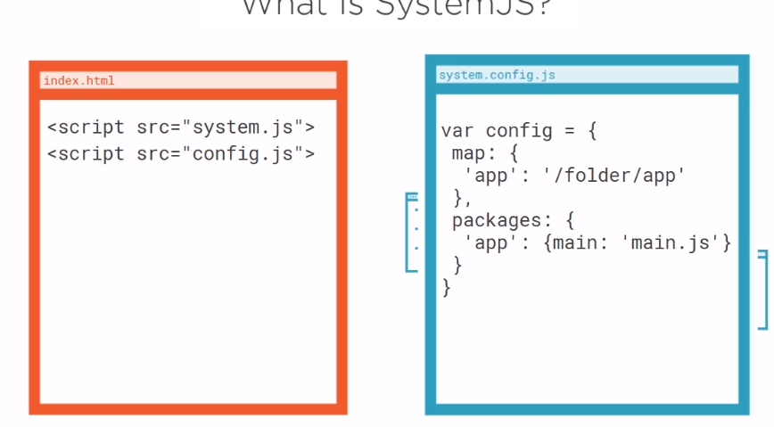

**Typescript Overview:** Superset of JavaScript. It is just a syntactical sugar transpilated via

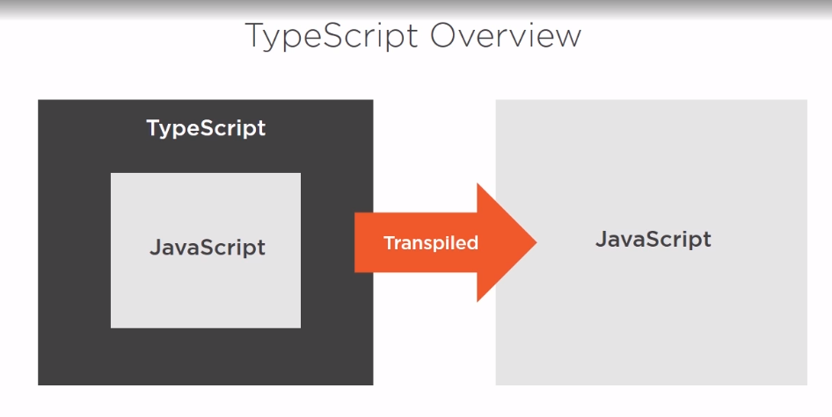

Static typing :

Typesciprt Interfaces ,

Typescript class properties : Es2015 way to class

|  |  |
| --- | --- |
|  |  |

The right side has more explicit property. You may want to enforce typesafty

Public and private accessibility: